Test Case: tc002_SPX_Dev5_Crear_Requisicion_Spot_Con_FAD_Tipo_Cobro_CC
Step 1 - Enter username and password and click to button Enter : Credentials Entered
Image file-name: QC_Testing-tc002_SPX_Dev5_Crear_Requisicion_Spot_Con_FAD_Tipo_Cobro_CC-1789483907370

Step 2 - Select to UEN and Access to Spot Buy Requisitions : UEN Correctly selected and Correct access
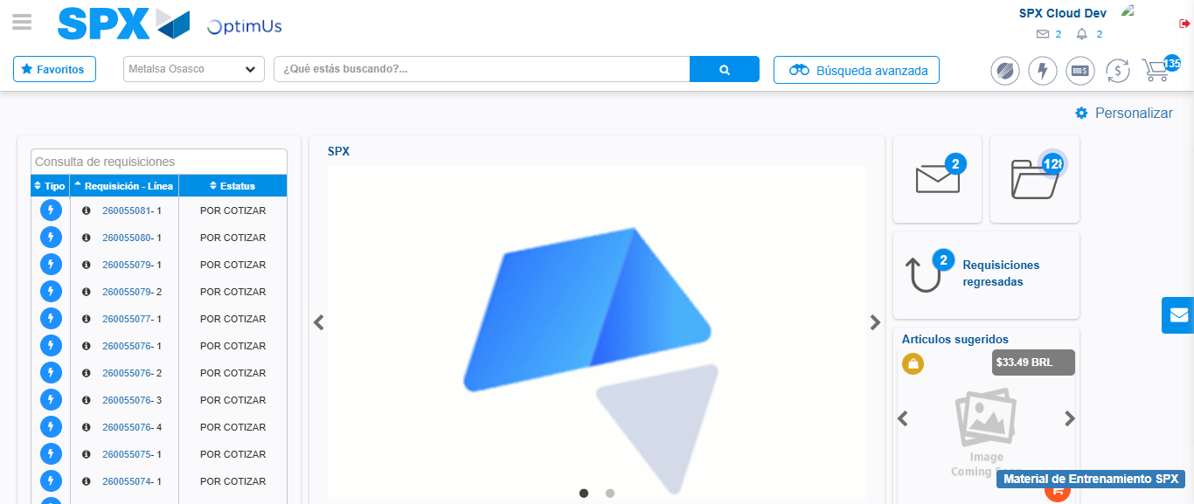Image file-name: QC_Testing-tc002_SPX_Dev5_Crear_Requisicion_Spot_Con_FAD_Tipo_Cobro_CC-1789483931260

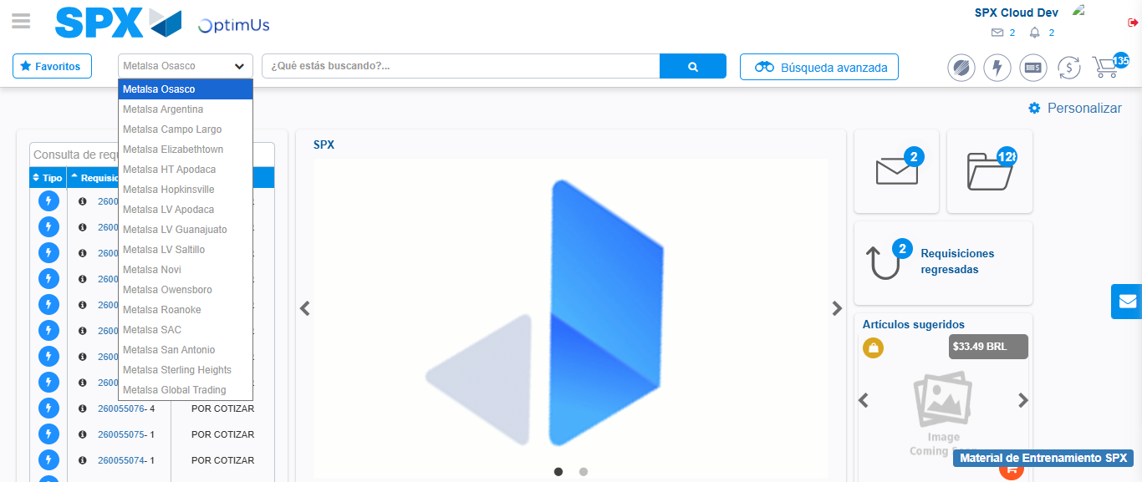Image file-name: QC_Testing-tc002_SPX_Dev5_Crear_Requisicion_Spot_Con_FAD_Tipo_Cobro_CC-1789483931826

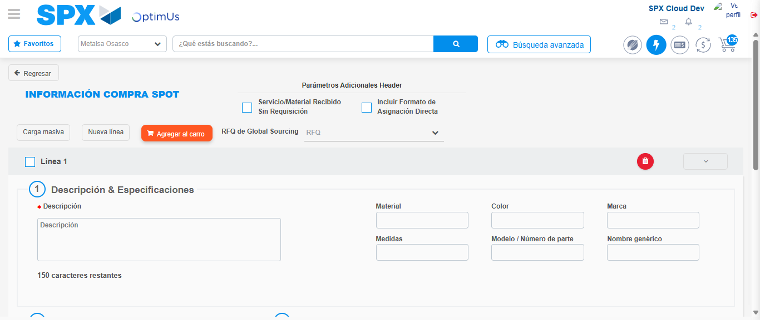Image file-name: QC_Testing-tc002_SPX_Dev5_Crear_Requisicion_Spot_Con_FAD_Tipo_Cobro_CC-1789483935840

Step 3 - Add FAD to Requisition: FAD Successfully Added
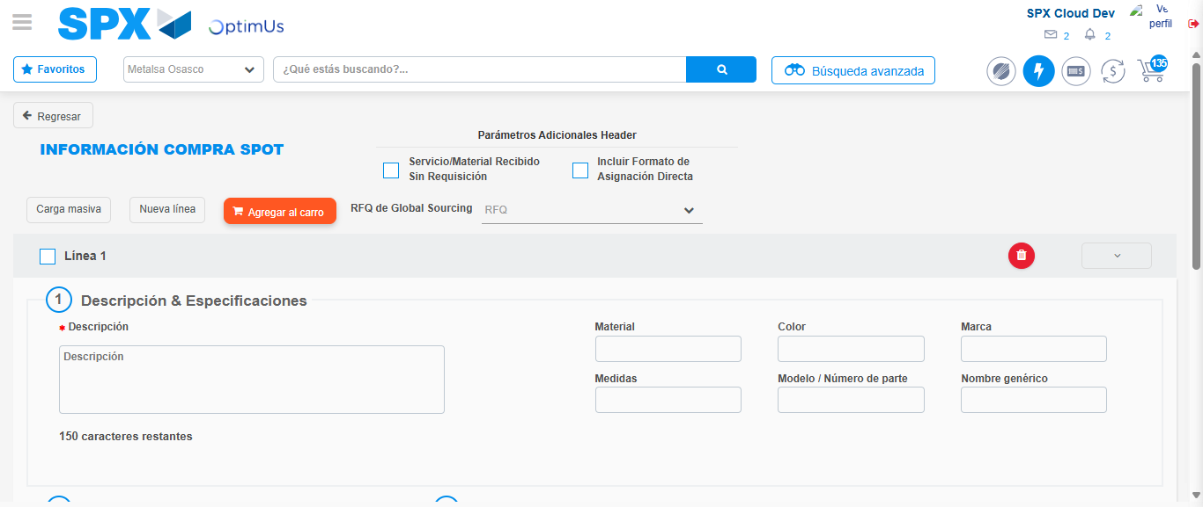Image file-name: QC_Testing-tc002_SPX_Dev5_Crear_Requisicion_Spot_Con_FAD_Tipo_Cobro_CC-1789483936159

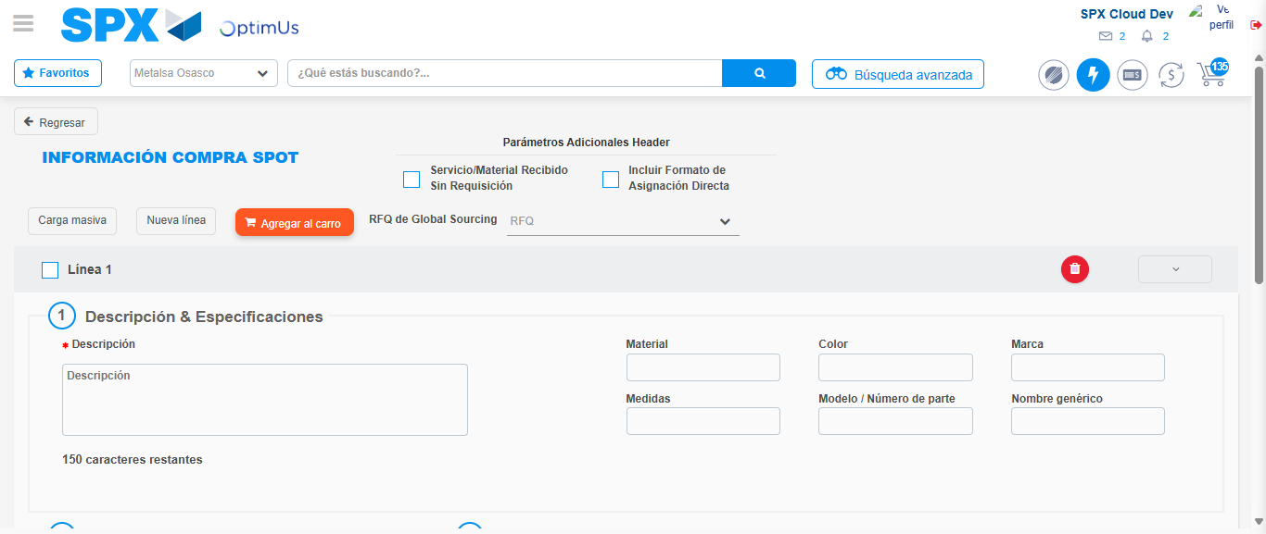Image file-name: QC_Testing-tc002_SPX_Dev5_Crear_Requisicion_Spot_Con_FAD_Tipo_Cobro_CC-1789483936406

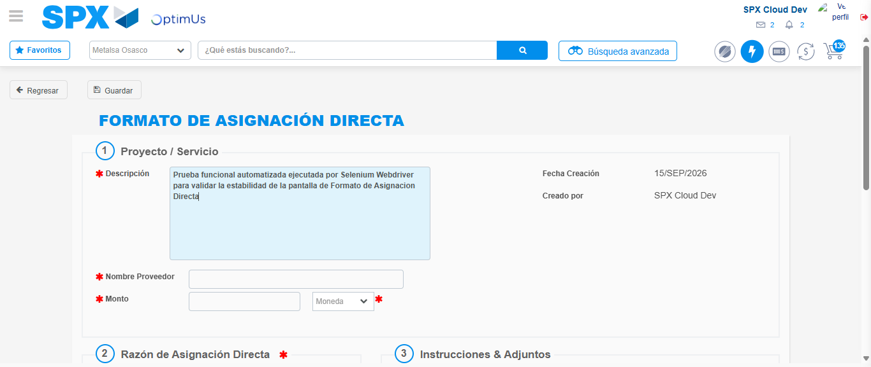Image file-name: QC_Testing-tc002_SPX_Dev5_Crear_Requisicion_Spot_Con_FAD_Tipo_Cobro_CC-1789483939120

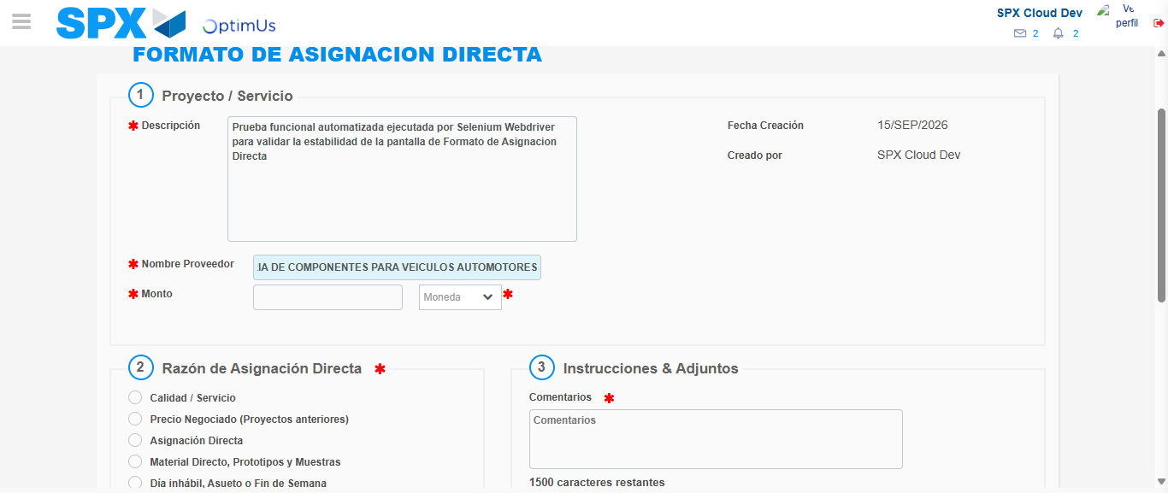Image file-name: QC_Testing-tc002_SPX_Dev5_Crear_Requisicion_Spot_Con_FAD_Tipo_Cobro_CC-1789483948062

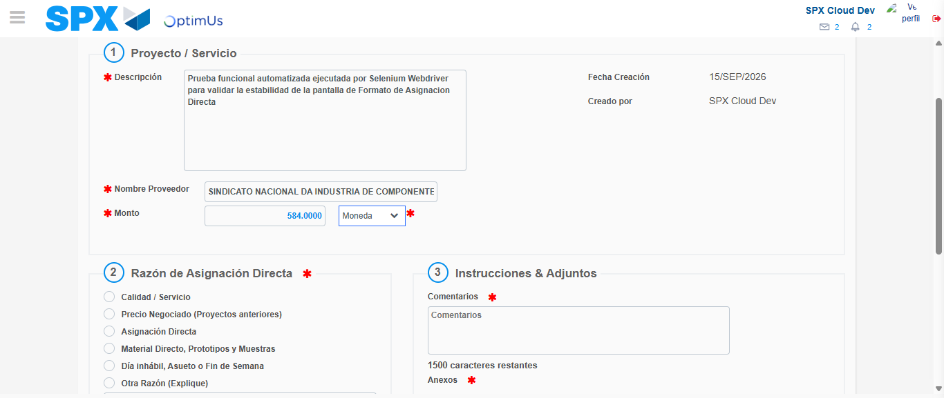Image file-name: QC_Testing-tc002_SPX_Dev5_Crear_Requisicion_Spot_Con_FAD_Tipo_Cobro_CC-1789483948481

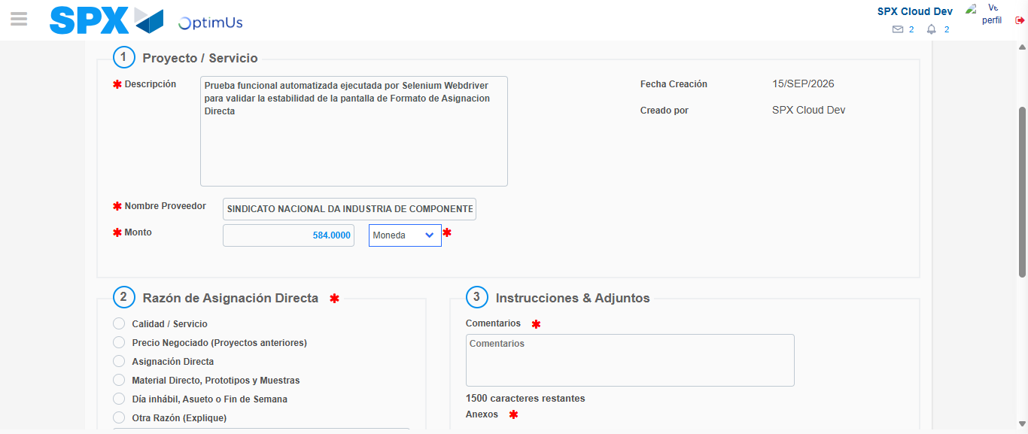Image file-name: QC_Testing-tc002_SPX_Dev5_Crear_Requisicion_Spot_Con_FAD_Tipo_Cobro_CC-1789483948711

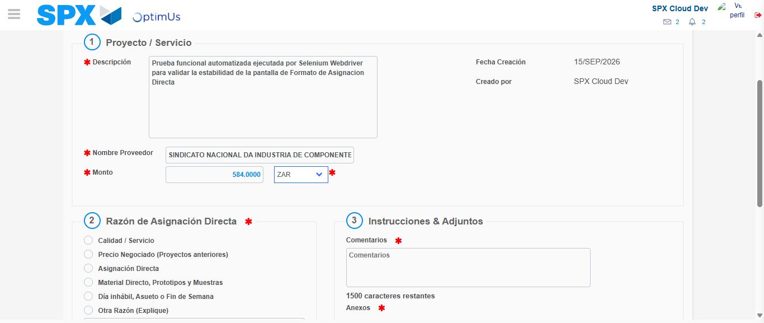Image file-name: QC_Testing-tc002_SPX_Dev5_Crear_Requisicion_Spot_Con_FAD_Tipo_Cobro_CC-1789483949055

Image file-name: QC_Testing-tc002_SPX_Dev5_Crear_Requisicion_Spot_Con_FAD_Tipo_Cobro_CC-1789483949255

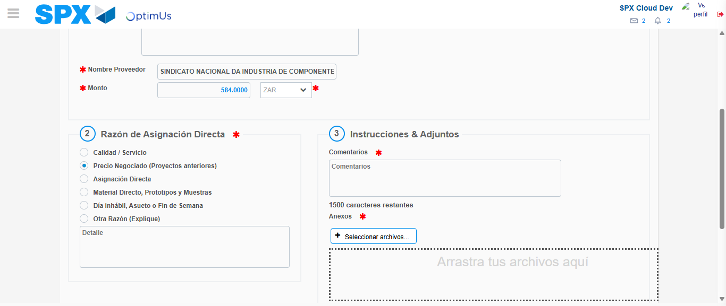Image file-name: QC_Testing-tc002_SPX_Dev5_Crear_Requisicion_Spot_Con_FAD_Tipo_Cobro_CC-1789483950059

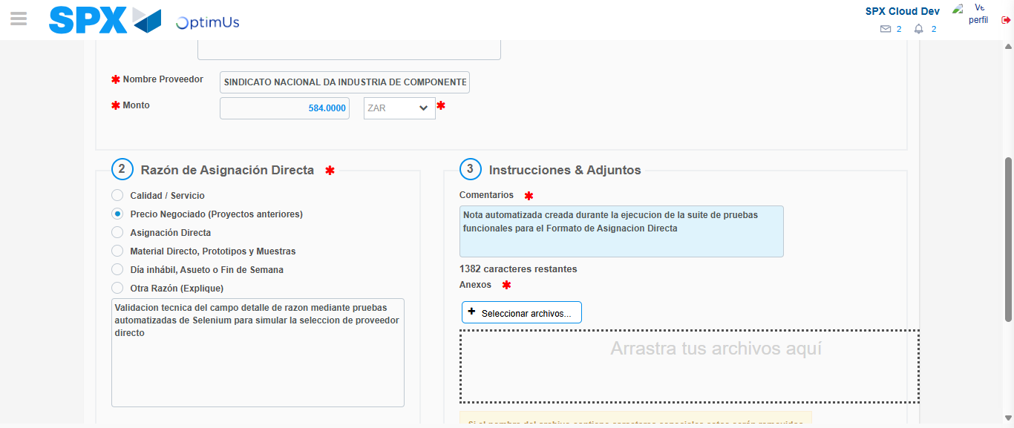Image file-name: QC_Testing-tc002_SPX_Dev5_Crear_Requisicion_Spot_Con_FAD_Tipo_Cobro_CC-1789483961014

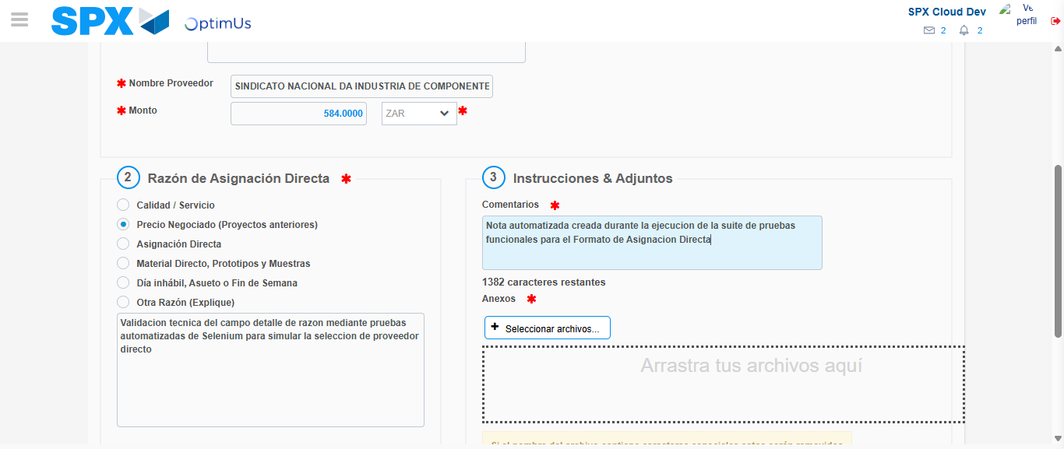Image file-name: QC_Testing-tc002_SPX_Dev5_Crear_Requisicion_Spot_Con_FAD_Tipo_Cobro_CC-1789483961731

Step 4 - Data Capture Spot Buy Requisition: Data captured correctly
Image file-name: QC_Testing-tc002_SPX_Dev5_Crear_Requisicion_Spot_Con_FAD_Tipo_Cobro_CC-1789483936159

Image file-name: QC_Testing-tc002_SPX_Dev5_Crear_Requisicion_Spot_Con_FAD_Tipo_Cobro_CC-1789483936406

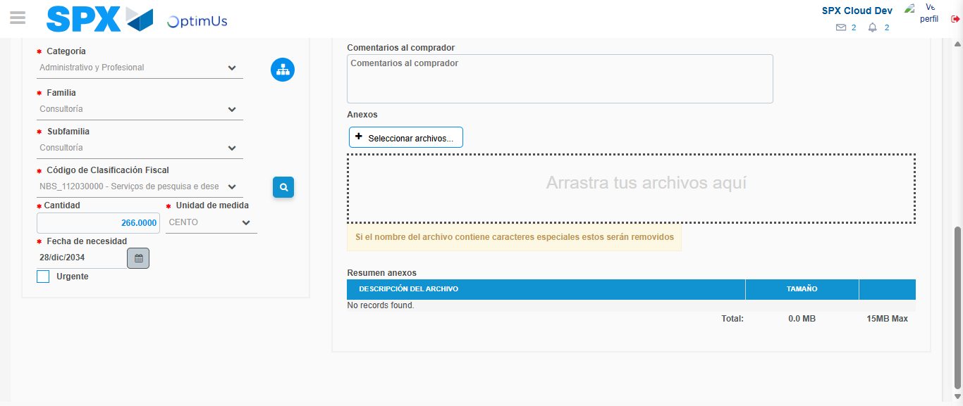Image file-name: QC_Testing-tc002_SPX_Dev5_Crear_Requisicion_Spot_Con_FAD_Tipo_Cobro_CC-1789483983588

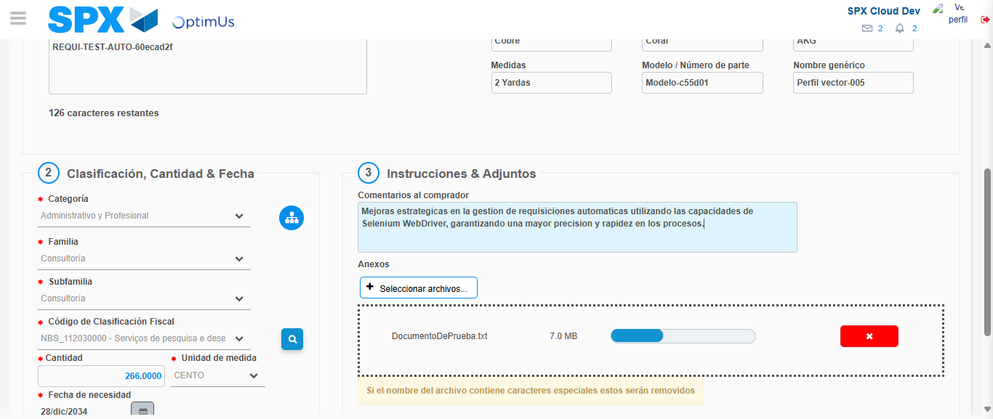Image file-name: QC_Testing-tc002_SPX_Dev5_Crear_Requisicion_Spot_Con_FAD_Tipo_Cobro_CC-1789483984295

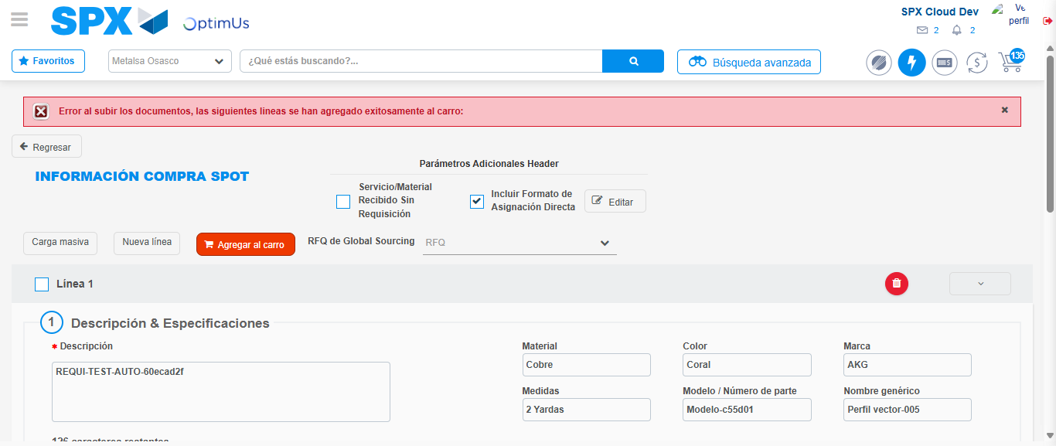Image file-name: QC_Testing-tc002_SPX_Dev5_Crear_Requisicion_Spot_Con_FAD_Tipo_Cobro_CC-1789484000224

Step 8 - Return to Main Page SPX : Return to Main Page SPX
Image file-name: QC_Testing-tc002_SPX_Dev5_Crear_Requisicion_Spot_Con_FAD_Tipo_Cobro_CC-1789483931260

Image file-name: QC_Testing-tc002_SPX_Dev5_Crear_Requisicion_Spot_Con_FAD_Tipo_Cobro_CC-1789483931826

Image file-name: QC_Testing-tc002_SPX_Dev5_Crear_Requisicion_Spot_Con_FAD_Tipo_Cobro_CC-1789483935840

Image file-name: QC_Testing-tc002_SPX_Dev5_Crear_Requisicion_Spot_Con_FAD_Tipo_Cobro_CC-1789484002506

Image file-name: QC_Testing-tc002_SPX_Dev5_Crear_Requisicion_Spot_Con_FAD_Tipo_Cobro_CC-1789484002690

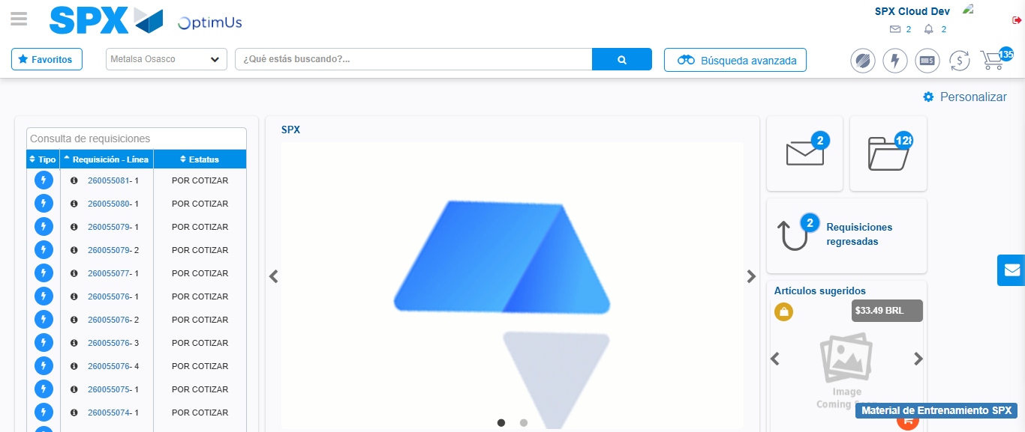Image file-name: QC_Testing-tc002_SPX_Dev5_Crear_Requisicion_Spot_Con_FAD_Tipo_Cobro_CC-1789484023770

Step 9 - Log Out : Log Out SPX
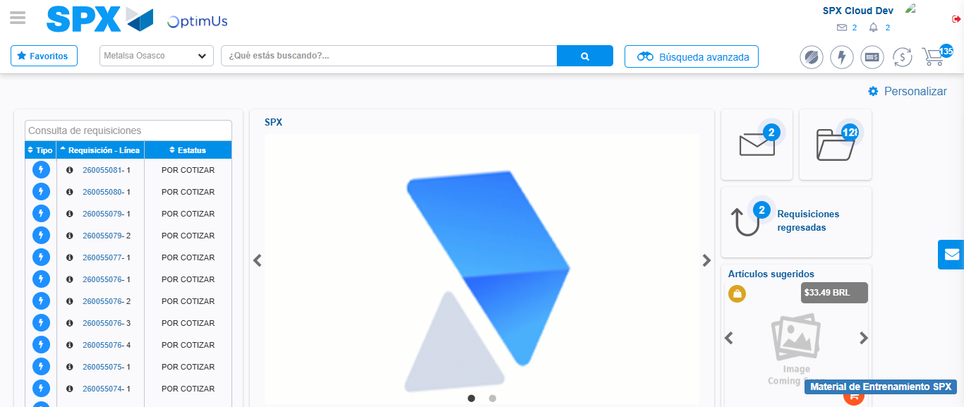Image file-name: QC_Testing-tc002_SPX_Dev5_Crear_Requisicion_Spot_Con_FAD_Tipo_Cobro_CC-1789484024021

